Reflexive Pronouns

🔹 What Are Reflexive Pronouns?
# Source: AI Source: Provided by: [Data Path: Persons Table -> ID Column: 1, Name_En Column: Motasem Essam] -> From: [Chatgpt (GPT-4-turbo)] on [7/27/2025]
Reflexive pronouns are used when the subject and the object of a sentence are the same person or thing.
They reflect the action of the verb back to the subject.

✅ List of Reflexive Pronouns
# Source: AI Source: Provided by: [Data Path: Persons Table -> ID Column: 1, Name_En Column: Motasem Essam] -> From: [Chatgpt (GPT-4-turbo)] on [7/27/2025]
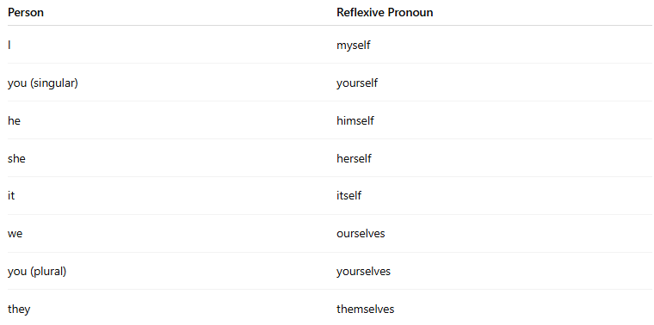
Person | Reflexive Pronoun
I | myself
you (singular) | yourself
he | himself
she | herself
it | itself
we | ourselves
you (plural) | yourselves
they | themselves

📚 Examples in Sentences
# Source: AI Source: Provided by: [Data Path: Persons Table -> ID Column: 1, Name_En Column: Motasem Essam] -> From: [Chatgpt (GPT-4-turbo)] on [7/27/2025]
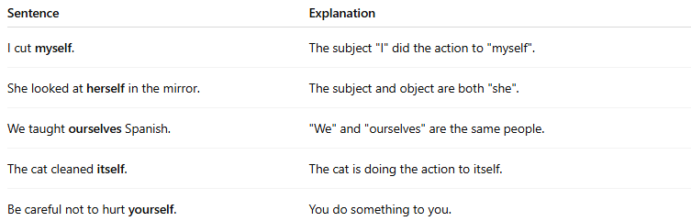
Sentence | Explanation
I cut myself. | The subject "I" did the action to "myself".
She looked at herself in the mirror. | The subject and object are both "she".
We taught ourselves Spanish. | "We" and "ourselves" are the same people.
The cat cleaned itself. | The cat is doing the action to itself.
Be careful not to hurt yourself. | You do something to you.

⚠️ Important Notes
# Source: AI Source: Provided by: [Data Path: Persons Table -> ID Column: 1, Name_En Column: Motasem Essam] -> From: [Chatgpt (GPT-4-turbo)] on [7/27/2025]
- Reflexive pronouns are always used when the subject = object.
- Do not use reflexive pronouns when the subject and object are different.
🔻 Incorrect:
She gave the gift to herself. (if she gave it to someone else)
✅ Correct:
She gave the gift to her. (different person)

🧠 Reflexive vs. Emphatic (Intensive) Pronouns
# Source: AI Source: Provided by: [Data Path: Persons Table -> ID Column: 1, Name_En Column: Motasem Essam] -> From: [Chatgpt (GPT-4-turbo)] on [7/27/2025]

Reflexive Use | Emphatic Use
He blamed himself. | He himself fixed the car.
(Used as object of the verb) | (Used for emphasis, not as object)

